CTCS-035 – BILLING INVOICE APP
@CREATIVITY THINK (9483175986/7019689991)

ABSTRACT:
The Billing Invoice App is a web-based platform designed to simplify invoicing, payment tracking, and analytics for freelancers, small businesses, and consultants. Users can create and edit invoices, manage customer databases, download or email PDF invoices, and track payment status. Administrators manage invoices, review payment statistics, and analyze dashboard analytics. Built with Django and Django Rest Framework for backend operations, and React with PDFKit and Recharts for frontend visualization, the system provides secure, real-time invoicing, business analytics, and reporting. This platform improves financial management, reduces manual errors, and enhances productivity for small enterprises..

INTRODUCTION OF THE PROJECT:
Effective billing and invoicing are critical for small businesses and freelancers to maintain accurate financial records, track payments, and analyze business performance. Traditional manual billing methods are time-consuming and prone to errors. The Billing Invoice App offers a centralized system for creating invoices, managing customer information, tracking payments, and visualizing financial data through dashboards. Administrators can oversee all financial operations and analyze payment trends. Using Django for backend logic and React with PDFKit and Recharts for frontend interactivity, the system ensures seamless, secure, and efficient invoice management and reporting..

PROJECT OBJECTIVES:

• Develop a centralized platform for creating and managing invoices
• Maintain a comprehensive customer database for accurate billing
• Track payment status and generate reminders
• Provide downloadable and email-ready PDF invoices
• Enable administrators to review invoices and payments
• Generate visual analytics and reports for financial insights
• Reduce manual effort and improve accuracy in billing operations

PROBLEM OF THE STATEMENT:
Freelancers and small businesses often struggle with manual invoice generation, payment tracking, and financial reporting. Traditional methods are prone to errors, delayed tracking, and lack of data visualization for business insights. Customers may face delays or confusion due to inconsistent invoice records. Administrators have difficulty monitoring payments, generating reports, and analyzing financial trends efficiently. The Billing Invoice App addresses these issues by providing a web-based platform for real-time invoice creation, payment tracking, PDF export, and dashboard analytics, ensuring accurate billing, timely updates, and informed financial decision-making..

MOTIVATION OF THE PROJECT:
• Streamline invoicing and billing processes for small businesses
• Reduce manual errors and improve payment tracking accuracy
• Provide PDF export for professional invoice delivery
• Enable data-driven decision-making through analytics dashboards
• Centralize customer and invoice management for efficiency

BLOCK DAIGRAM OF PROJECT:

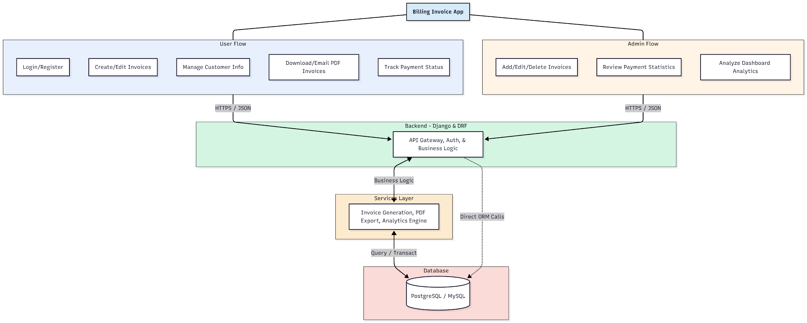

WORKING OF THE PROJECT:
Users register or log in to create and edit invoices, manage customer information, and track payment status. PDF invoices can be downloaded or emailed to clients for professional delivery. The backend handles authentication, business logic, and API requests, while the services layer manages invoice generation, PDF export, and analytics. Administrators can add, edit, or delete invoices, review payments, and analyze overall business performance via a dashboard. The integrated system ensures real-time invoice management, accurate tracking, and business insights, streamlining financial operations for freelancers and small enterprises..

SOFTWARE REQUIREMENT:
- Backend:
  - Python 3.x
  - Django
  - Django REST Framework
  - SQLite/PostgreSQL
- Frontend:
  - Node.js and npm
  - React.js
  - Axios
- Development Tools:
  - Visual Studio Code
  - Postman (for testing APIs)
  - Git/GitHub (for version control)
- Server/Deployment (Optional):
  - Gunicorn, Nginx, or Heroku/AWS for hosting

ADVANTAGES OF THE PROJECT:

• Centralized invoice creation and management
• Track payment status in real-time
• Export invoices as PDF for professional delivery
• Visualize financial analytics via dashboards
• Reduce manual errors in billing
• Improve workflow efficiency for freelancers and businesses
• Administrators can manage all invoices and payments
• Provides actionable insights for better business decisions

APPLICATIONS OF THE PROJECT:
• Freelancers and independent consultants
• Small business invoice management
• Accounting and bookkeeping services
• Client billing for service-based businesses
• Payment tracking for recurring invoices
• Dashboard analytics for financial insights
• Exportable reports for audits
• Cloud-based invoice management systems

REFERENCES:

- Django REST Framework Documentation — Django Software Foundation. Django Documentation. Available: https://docs.djangoproject.com/
- Django REST Framework. DRF Documentation. Available: https://www.django-rest-framework.org/
- React. React Official Documentation. Available: https://reactjs.org/docs/getting-started.html
- Redux. Redux Documentation. Available: https://redux.js.org/introduction/getting-started
- PostgreSQL Global Development Group. PostgreSQL Documentation. Available: https://www.postgresql.org/docs/
- MySQL. MySQL Reference Manual. Available: https://dev.mysql.com/doc/
- Git. Git Documentation. Available: https://git-scm.com/doc
- Node.js. Node.js Documentation. Available: https://nodejs.org/en/docs/
- Axios. Axios Documentation. Available: https://axios-http.com/docs/intro
- Socket.io Documentation – https://socket.io/docs/

